Commerce Bank Customer Transaction Portal

User Guide

Team 4

December 2, 2019

Team Members
Uhura Ruth
Nicholas Wiegand
Jorge Lopez-Flores
Scott Peery
Kenneth Harris

Contents
Contents 2
1 Introduction 3
2 System Requirements 3
3 Quick Start Guide 3
4 Main Scenarios of Use 4
5 Troubleshooting 8

Introduction
The Commerce Bank Customer Transaction Portal is intended to give bank customers a way to quickly and easily review the transactions that have taken place in their back account. They also will be allowed to create their own business rules and receive notifications about them so they may monitor, categorize, and analyze the transactions involving their bank account. This document will provide instructions for using the application to view bank accounts, set Custom Alerts, and export Custom Alert/Transaction data to Excel for personal use.

System Requirements
Currently, the Customer Transaction Portal has not been deployed to a production environment. Therefore, in order to run the application, refer to the System Guide to set up a development environment for the program to function.
If deployed on a production server, users should only need an internet browser in order to view the web page. Currently, we only guarantee support for Google Chrome

Quick Start Guide
1. Navigate to the Transaction Portal webpage in Google Chrome (in development environment, run the program from Visual Studio)
2. If logged into a valid user account, you should be directed to the Home page which displays your bank account data
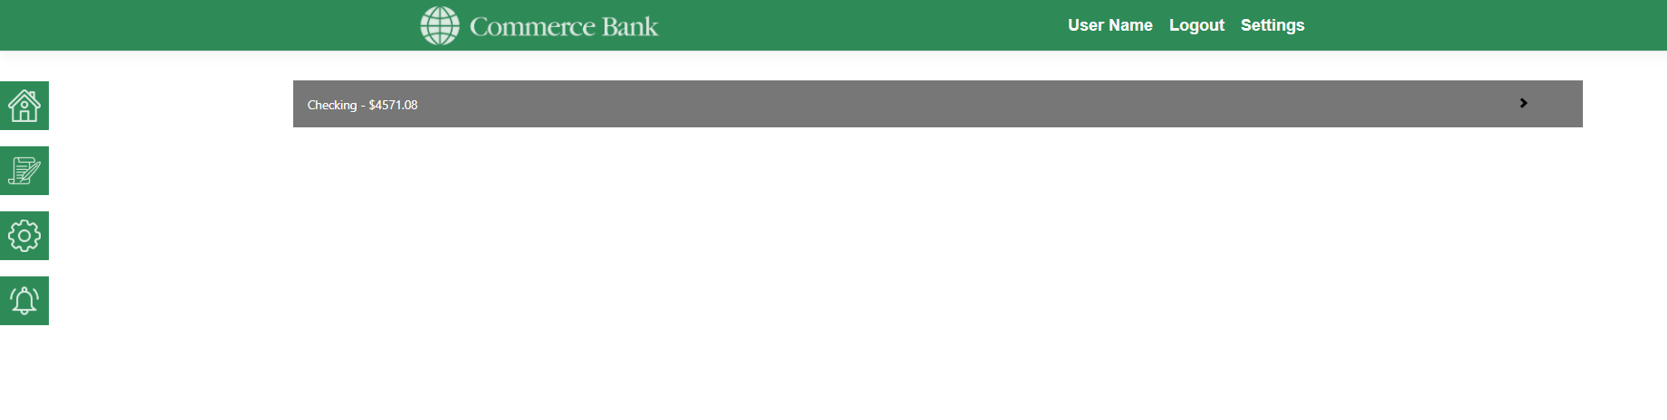

Main Scenarios of Use

View Bank Account(s) Ledger
4. Use mouse to navigate page if scrolling is needed
1. Navigate to the Transaction Portal webpage (in development, run the program)
2. Log into a user account if not already logged in
3. Click on the collapsible(s) for the account(s) to view the transactions in that account
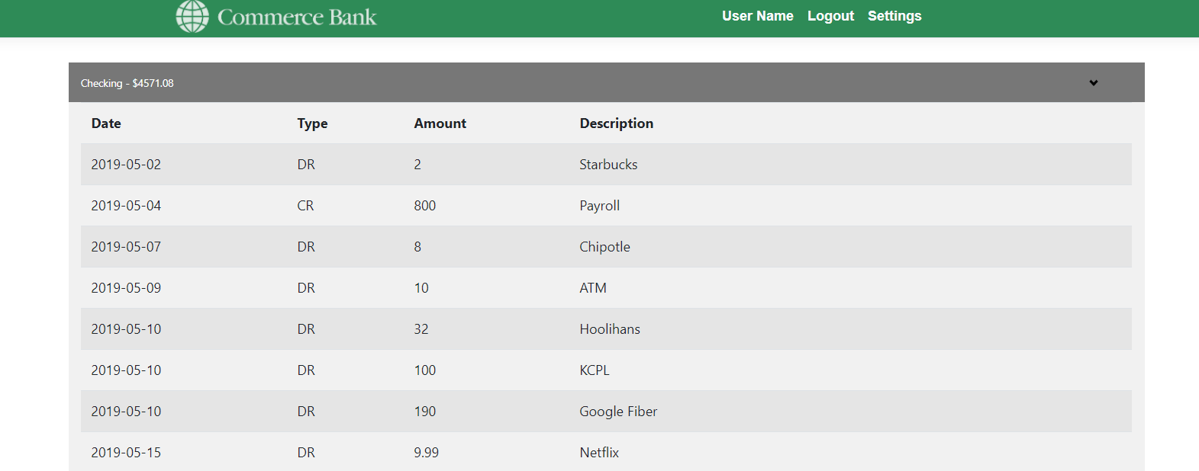

Manage Custom Alerts
1. From home page, click on Custom Alerts icon on left side of page. It looks like a gear wheel
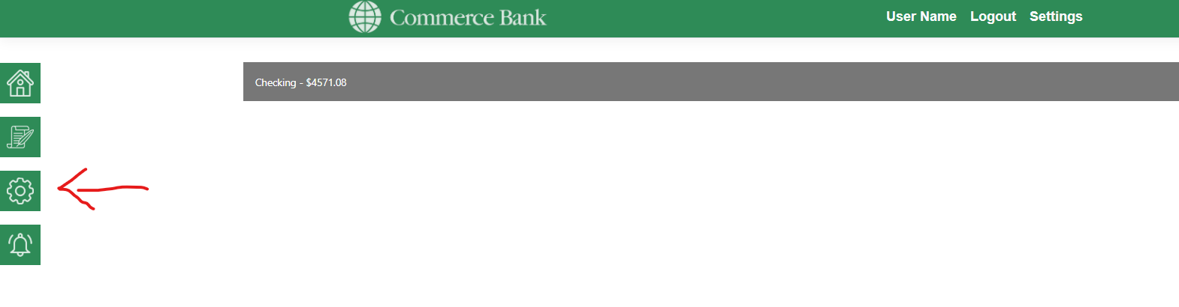

2. Name new Custom Alert
3. Select trigger from drop-down option
4. Enter value type for trigger selected
5. Click Create button
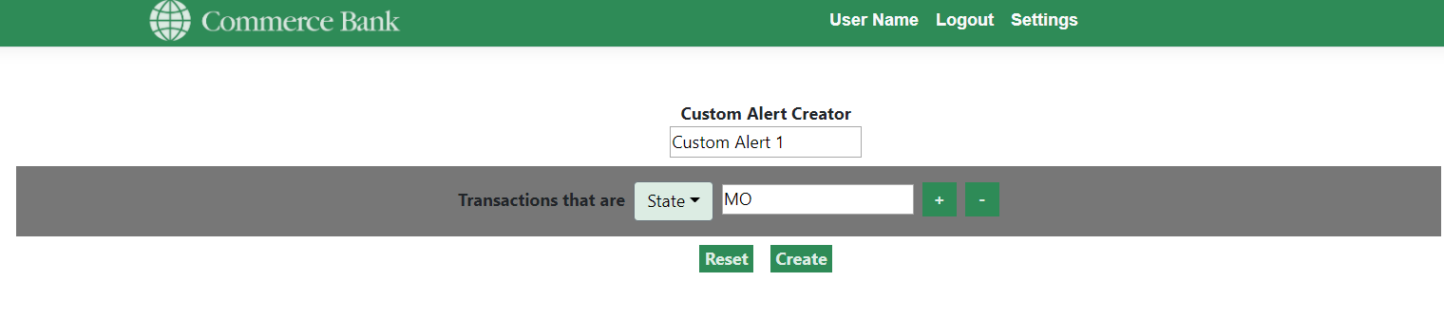
6. Click on Alerts dropdown banner to verify your Custom Alert was created
7. (Optional) Select the custom alert you wish to edit/delete
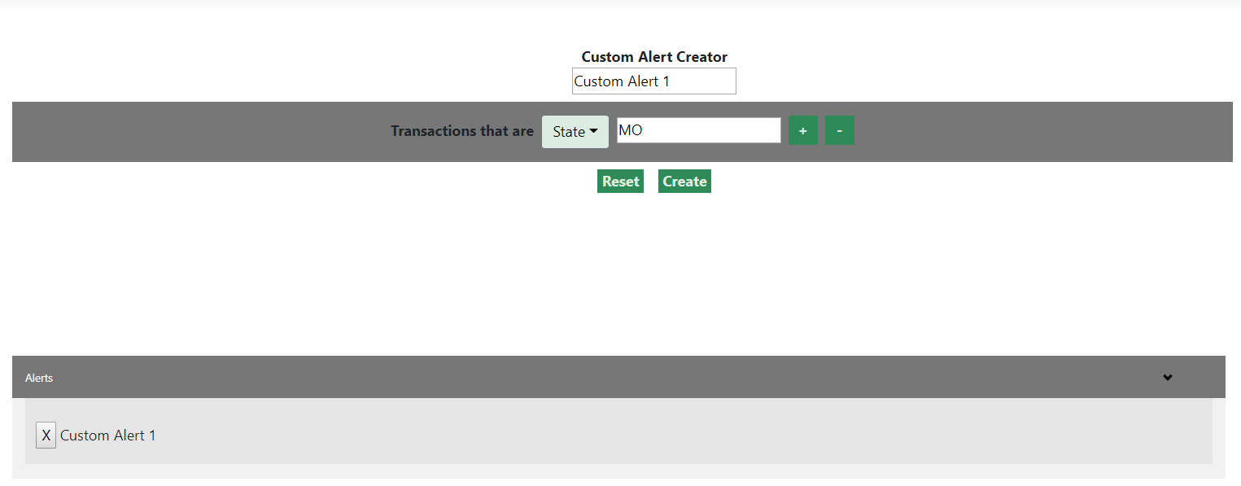

4.3 View/Export Alert Reports
1. From home page, click on the Reports icon on the left side of the page. It looks like a scroll with a feather pen writing across it
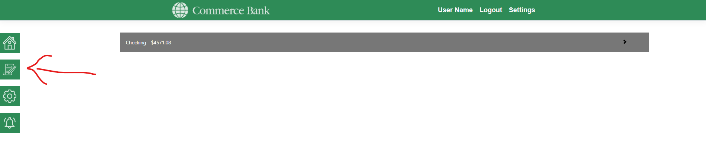
2. Click on the Alerts dropdown banner
3. Select the Alert you wish to see data for
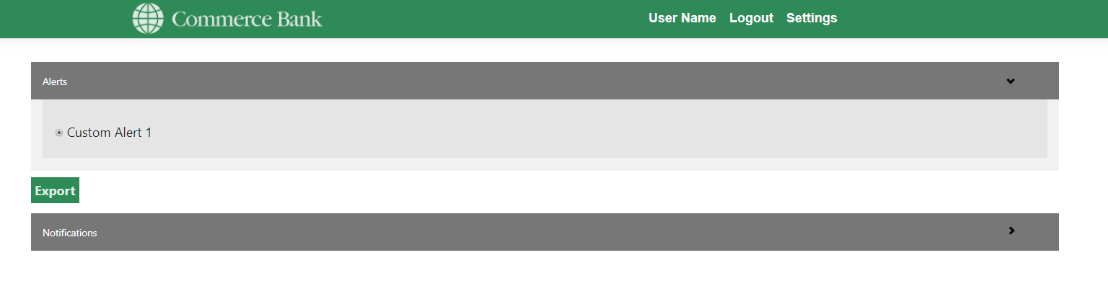
4. Click on the Notifications dropdown banner to see all the transactions that have triggered the Custom Alert
5. (Optional) Click export button
6. (Optional) A link to the spreadsheet in your Downloads folder should appear in your browser. Click the link to open/print the spreadsheet, or right-click to open the file location and move the spreadsheet as you wish.

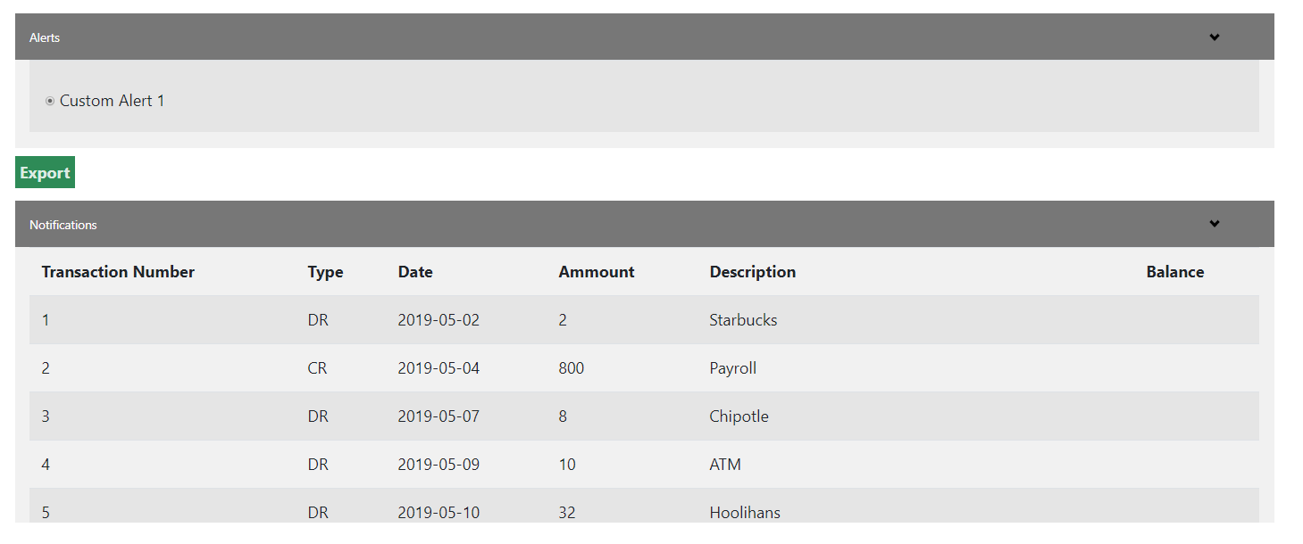
Fully expanded Reports page

4.4 Notifications
Alternatively, you can use the Notifications Icon on the Navigation Menu to quickly see if alerts have been triggered and navigate to their specific reports page.
1. Move the mouse cursor over to the Notifications Icon and hover your mouse over the button.
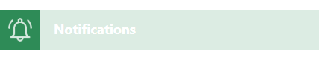
2. Click on the Icon to display any new notifications
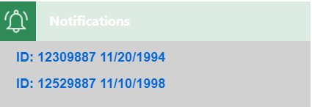
3. Click on a link to a Notification. You will be redirected to the reports page for that specific Custom Alert

Troubleshooting

New Custom Alerts Not Showing Up/Incorrect Input
If a Custom Alert is missing a Name or a Trigger, the Create button will not create the alert, but your input will still be there. As of now, no error message displays when this happens. Be sure to check the Alerts drop down at the bottom of the page to ensure Custom Alerts are created/stored properly.
Custom Alerts can be created without a value. However, they will not return any notifications/transaction data. If this mistake is made, use the “Alerts” drop down to delete the erroneous alert.
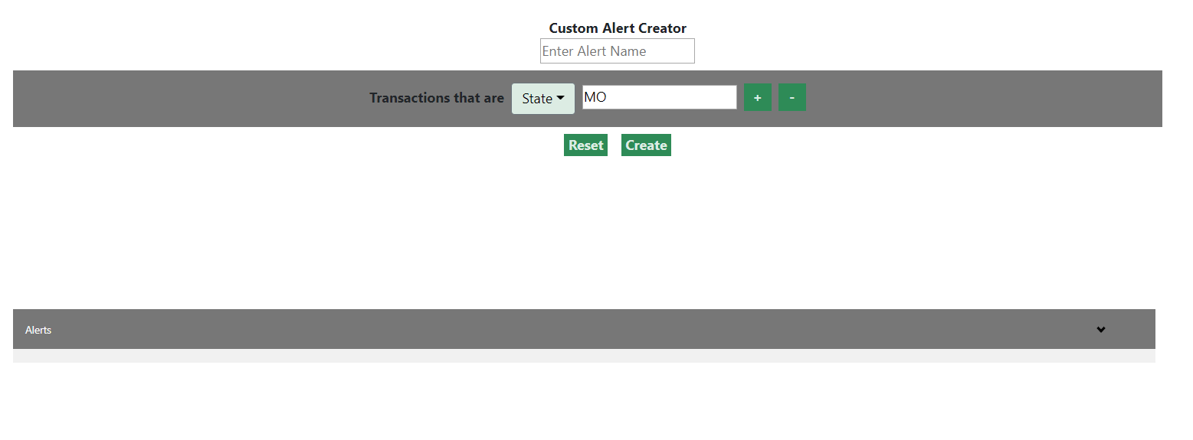 "Create" button was clicked, yet no alert was created

